**Analytics Cases: Yammer**

Yammer is a social network for communicating with coworkers. Individuals share documents, updates, and ideas by posting them in groups. Yammer is free to use indefinitely, but companies must pay license fees if they want access to administrative controls, including integration with user management systems like ActiveDirectory.

Yammer has a centralized Analytics team, which sits in the Engineering organization. Their primary goal is to drive better product and business decisions using data. They do this partially by providing tools and education that make other teams within Yammer more effective at using data to make better decisions. They also perform ad-hoc analysis to support specific decisions.

**The Yammer analytics philosophy**

Yammer analysts are trained to constantly consider the value of each individual project; they seek to maximize the return on their time. Analysts typically opt for less precise solutions to problems if it means investing substantially less time as well.

They are also taught to consider the impact of *everything* on the company at large. This includes high-level decision making like choosing which projects to prioritize. It also influences the way analysts think about metrics. Product decisions are always evaluated against core engagement, retention, and growth metrics in addition to product-specific usage metrics (like, for example, the number of times someone views another user’s profile).

There are three cases to analyze:

**A Drop In Case Engagement**

Engagement dips—you figure out the source of the problem.

**Understanding Search**

The product team is thinking about revamping search. Your job is to figure out whether they should change it at all, and if so, what should be changed.

#### [The Best A/B Test Ever](https://community.modeanalytics.com/sql/tutorial/validating-ab-test-results/)

A new feature tests off the charts. Your job is to determine the validity of the experiment.

In this report, I would be working with Drop In User Engagement to find and suggest the analysis method.

**Investigating a Drop In User Engagement**

Yammer’s Analysts are responsible for triaging product and business problems as they come up. In many cases, these problems surface through key metric dashboards that execs and managers check daily.

**Problem Statement**

You show up to work Tuesday morning, September 2, 2014. The head of the Product team walks over to your desk and asks you what you think about the latest activity on the user engagement dashboards. You fire them up, and something immediately jumps out:

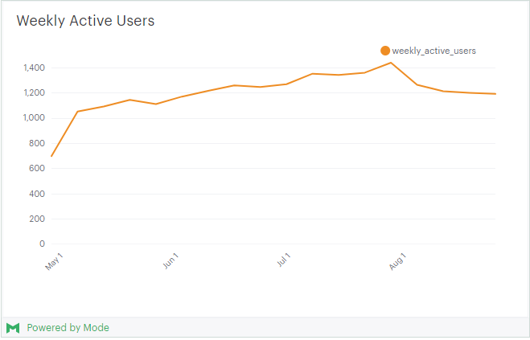

The above chart shows the number of engaged users each week. Yammer defines engagement as having made some type of server call by interacting with the product (shown in the data as events of type “engagement”). Any point in this chart can be interpreted as “the number of users who logged at least one engagement event during the week starting on that date.”

You are responsible for determining what caused the dip at the end of the chart shown above and, if appropriate, recommending solutions for the problem.

There are four tables that has been used for the purpose of this case study. It is similar in structure to Yammer’s actual data, but for privacy and security reasons it is not real.

**Table 1 : Users**

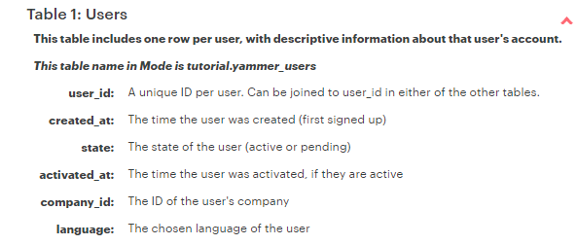

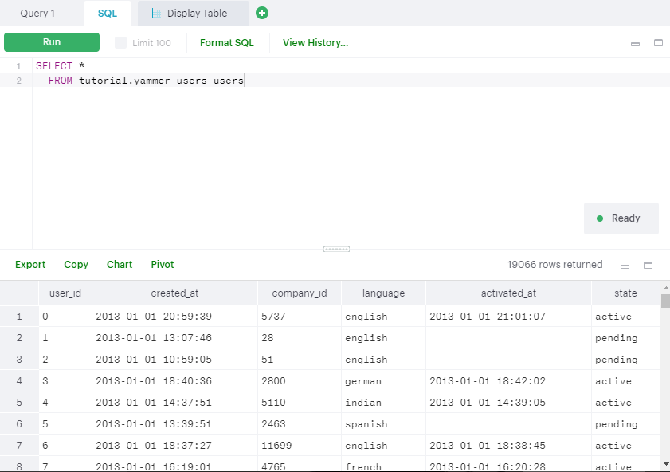

**Table 2: Events**

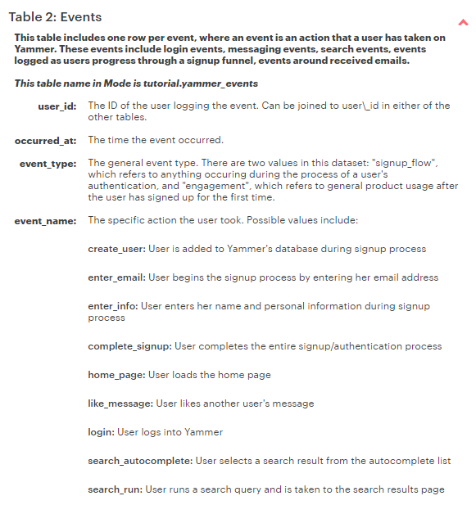

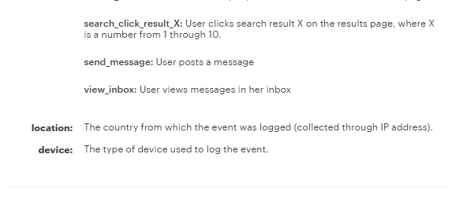

This table contains information about the events itself and the actions taken by users on yammer. These events include log in events, messaging events, search events, events logged as users progress through a signup funnel and events around received emails.

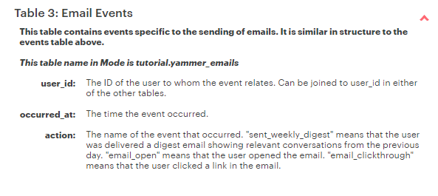

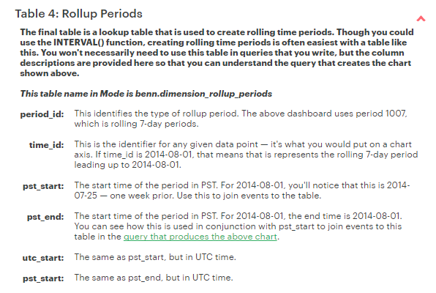

From the users table, the total number of active users as opposed to all users is checked in order to find the trend whether the growth in user base remains the same or not.

Initially, the growth of active users with respect to total users has been observed. The following Query has been used in order to see the rate of change of activated_users and all_users and which day of the month since June 1st,2014.

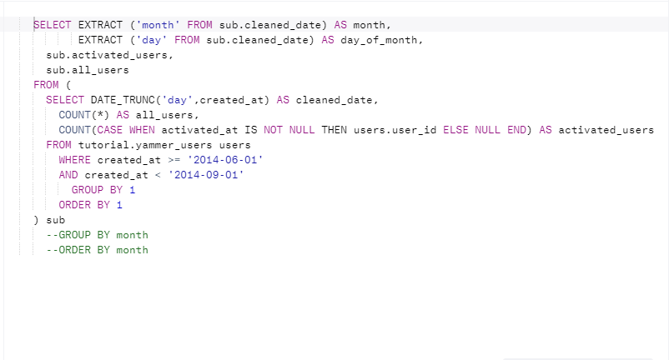

The above query returns the following table.

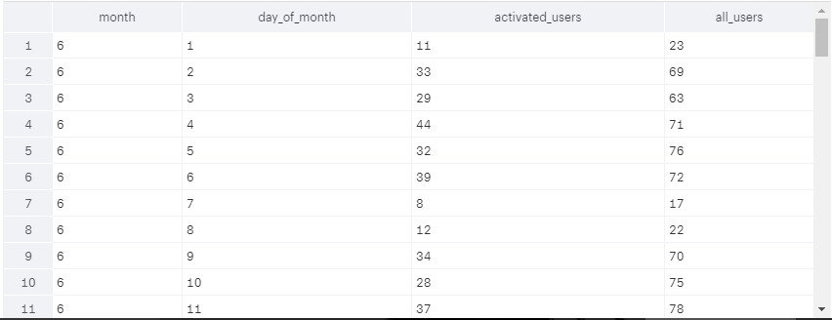

In order to observe the growth ratio of the users from that timespan, this following query has been written.

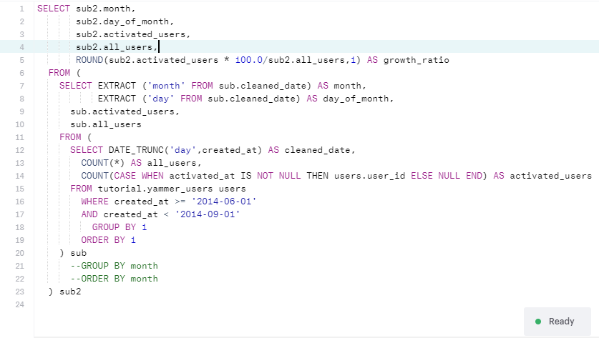

The above query returns this following results showing a steady percentage of growth of the users.

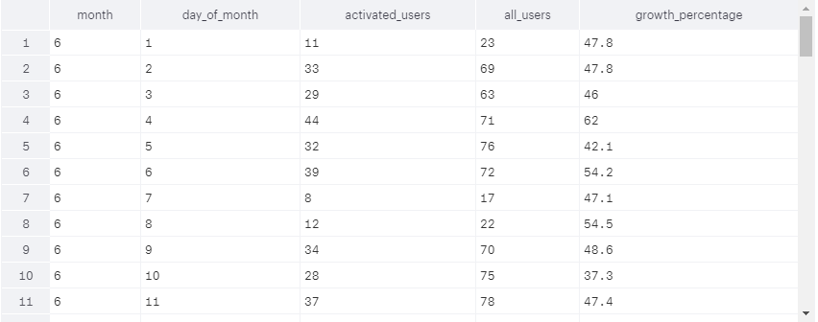

Therefore, we can conclude that not a significant proportion of the users stopped engaging to the software.

Since the growth is normal, therefore it might be possible that the dip in engagement may come from the existing users as opposed to new users. One of the best effective way to look into the dip in engagement is to observe the timeline of the signup for the product.

To find a distribution of the user activation time and engagement period, the following query has been written.

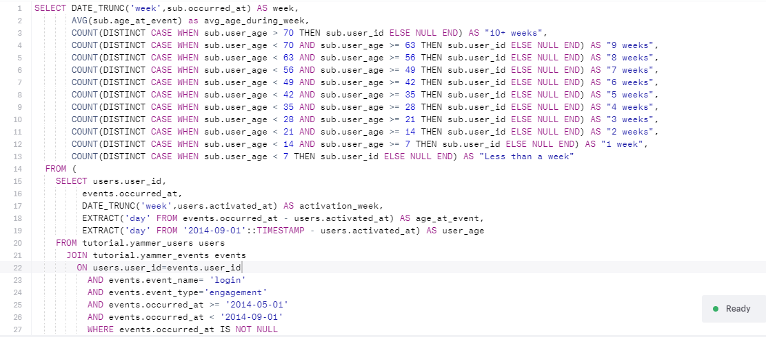

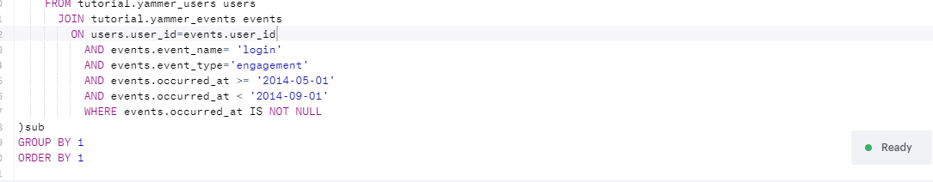

The query returns the following result.

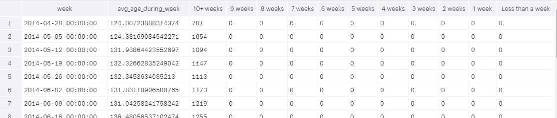

From the above query it has been confirmed that it is not the new users' that is causing the dip in the engagement dashboards but the existing old users that are already registered in the system.

The third step would be to see where this existing users are from and the time of the traffic exchanges from that geographic regions and the devices that they used.

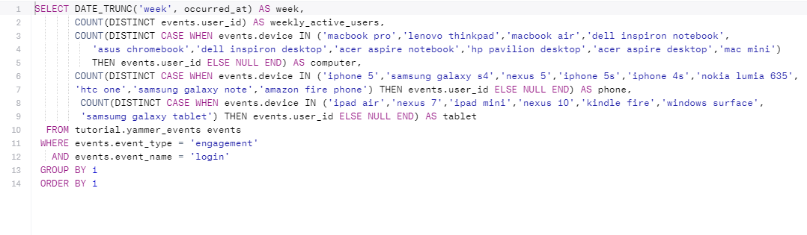

The above query returns the following results which shows a dip in the phone users.

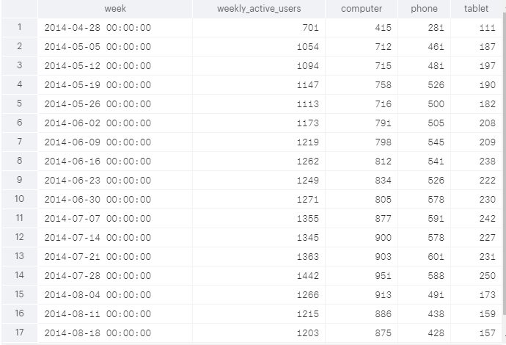

Therefore, it can be concluded that there was a problem with the phone apps that caused the dip in the engagement.